|  |
| --- |
|  |
| Project Plan |
|  |

|  |
| --- |
|  |

Contents

Project goals 3

Project Deliverables 3

Project Schedule 3

Supporting Plans 5

Human Resource Plan 5

Communication Plan 5

Risk Management Plan 5

Time estimates too optimistic:- 5

Supervisor review and feedback too slow:- 5

Stakeholder needs are not properly understood:- 6

Stakeholders changing requirements after the project has started:- 6

Stakeholders adding new requirements after the project has started:- 6

Poor communication resulting in misunderstandings, quality problems and rework:- 6

Lack of resource commitment:- 6

# Project goals

To plan the goals of the project an initial meeting was held to discuss the stakeholders of the project and to plan the goals around them. Through the meeting the stakeholders that were agreed upon would be the users that would be using the finished project and the supervisor who would be receiving the project. Now that the stakeholder had been realised it became easier to make more specific goals that could be worked towards and achieved. For the first website which would be under the supervision of Christine Thomas the stakeholders would be the users of the final project and the supervisor who receives the completed project. For users the goals would be to supply them a way to apply to the event and to provide the necessary information. The goals of the supervisor is to have a website that advertises the upcoming event and provides all the information they want to give out to potential visitors and exhibitors. The second website would be under the supervision of David Beckett who agreed upon the same stakeholders, users and himself who would receive the finished project. The users gaols would be to provide them with all the information they might want about the club and some background information of Bedford vehicles in general. Should the information be enough to entice them they would also want a way to apply to the club. The goals of the supervisor are to create a website that informs potential fans of the new Bedford fan club that is being created, information about the current vehicles that are being kept or restored on the grounds, a brief history of the Bedford company and vehicles and a page about applying.

# Project Deliverables

The first website will need to be informative, giving the user the necessary information clearly about the upcoming event. This should be done by the first review meeting on the 10th of January 2013. It will also need a way to apply to the event, either as a visitor or as an exhibitor, which will be done for the second review meeting on the 7th of February 2013. The second website will need to have a page to inform the users all about the club and who it is for which will be done for the 10th of January 2013.It will also need a way to apply to become a member of the club which will be done for the second review meeting on the 17th of January 2013.

# Project Schedule

All tasks and deadlines have been shown below with the Gantt chart on Page 4. The dates chosen are the estimate for this project. In the initial meeting the project was planned to finish at the end of February. This would be the deadline for the project. The review meeting which in the Gantt chart are blue are also deadline that will be met. The other tasks can have their time altered in they need to be as long as it doesn't affect the review dates or the final project deadline.

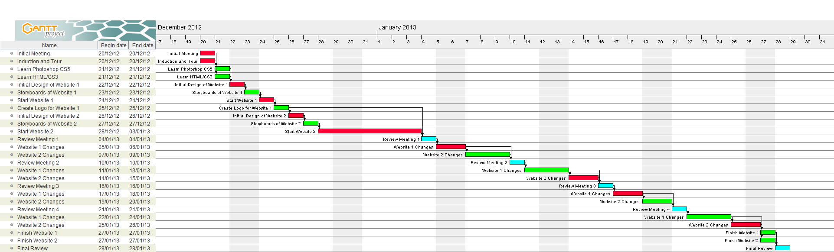



# Supporting Plans

This can be split into three sections. The human resource plan , the communication plan and the risk management plan.

## Human Resource Plan

Christine Thomas - Supervisor of the project for The Griffin Gathering website. She will provide any information that is needed for the website. She will also be reviewing the website at key stages. David Beckett - Supervisor of the project for The Bedford Club website. He will provide any information that is needed for the website. He will also be reviewing the website at key stages. The project will be created solely by myself. All people in the in the project team will be working together from Thursday 20th December 2012 to Thursday 27th February 2013.

## Communication Plan

Throughout the project both supervisor will need to be informed of the progress of each website. There will be a review meetings on the Thursday of every week to allow for the supervisor to access the progress themselves and give and instruction on areas that need to be changes or improved.

## Risk Management Plan

Risk management is an important part of the project management that is often overlooked but is necessary to identify and prepare, if possible, for risk to the project. Risks that could affect this project are:

### Time estimates too optimistic:-

This is an unlikely thing to happen as there is three months to create both websites however this could happen if more additions and requirements are added to the websites. This can be worked around within the project time by working more hours to get it done.

### Supervisor review and feedback too slow:-

This shouldn't be an issues with planned review meeting however if the supervisors were to cancel a meeting for whatever reason. Then the only way to get around it is to contact the supervisor email which could be a little responsive and result if slow feedback but faster than waiting a week for the next meeting. Another method is to book another meeting with the supervisors.

### Stakeholder needs are not properly understood:-

From the initial meeting the stakeholders should be understood however if at some point through the review it is realised there is a need not being met it can easily be fix or worked into the website as long as there is time.

### Stakeholders changing requirements after the project has started:-

This is a highly possible risk. The supervisor through the review meeting might find that they want different requirements that the website will not provide which will mean editing or even redoing the website. Depending on the time constraints this could be possible to fix however in order to prevent it happing the initial meeting should have made it clear what the requirements the stakeholders want.

### Stakeholders adding new requirements after the project has started:-

This is also a highly possible risk as through the project time the stakeholder may want more from the website such as more features. This is a little more difficult to prevent as the requirement could come from the review meetings and how well the project is progressing.

### Poor communication resulting in misunderstandings, quality problems and rework:-

As the supervisors have little knowledge of websites and how they should be design for the user they will have different view of what the website should look like and what is should contain. As a website development student it will be up to myself to

advise them on current styles and feature and help them to understand what is and isn't a good feature to insure that the quality of work doesn't drop and the website doesn't have to be reworked.

### Lack of resource commitment:-

It is unlikely that there will be a lack of resources as there will be review meeting and the initial meeting gave a lot of information on what they want from the project. If there is a lack of resource commitment then I will have to confront the supervisors and request the resources to insure the project meet the deadlines.